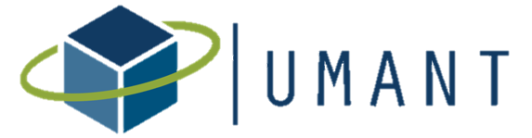
EXECUTIVE COMMITTEE MEETING

August 2nd 2019, 12:00 PM
City of Mesquite
757 N. Galloway Avenue.

As you walk in the main entrance of City Hall, you will make a right and the conference room is located at the end of the hall.
Dial in: 716-293-8199
PIN: 73102
https://www.uberconference.com/taylorlough

AGENDA
- Approval of June 7th Meeting Minutes
- Committee Updates
- Networking & Mentorship:
  - Trends and Tours update
- Special Events
  - One day conference update
- Professional Development
  - Legislative Update
  - Ethics Event
- Memberships & Partnerships
- Communications
- Approve the new mission statement:
The mission of the Urban Management Assistants of North Texas (UMANT) is to build and foster an authentic community of public servants through professional development and networking opportunities. UMANT will connect, inspire, and develop professionals and students in local government to benefit the community and organization they serve.
- Calendar Update
- Pitstick Scholarship Update
- Officer Elections
- Next meeting & closing comments
2019 Meetings:
September 6– City of Sachse
October 4– City of Southlake
November 1– City of Anna
December 6– City of Irving
MEETING NOTES

