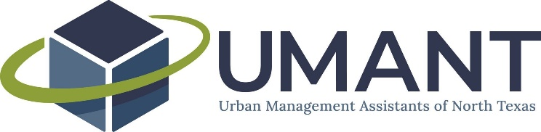

UMANT Executive Committee Agenda
August 20, 2021
2:00 PM – 3:00 PM
Virtual

Topic: new umant exec meeting 8-3-21
Time: Aug 6, 2021 02:00 PM Central Time (US and Canada)

Join Zoom Meeting
https://us02web.zoom.us/j/82034976912

Meeting ID: 820 3497 6912
One tap mobile
+13462487799,,82034976912# US (Houston)
+12532158782,,82034976912# US (Tacoma)

Dial by your location
+1 346 248 7799 US (Houston)
+1 253 215 8782 US (Tacoma)
+1 669 900 6833 US (San Jose)
+1 301 715 8592 US (Washington DC)
+1 312 626 6799 US (Chicago)
+1 929 205 6099 US (New York)
877 853 5257 US Toll-free
888 475 4499 US Toll-free
Meeting ID: 820 3497 6912
Find your local number: https://us02web.zoom.us/u/kwMBoEE1o

- Approval of May 7, 2021 and June 4, 2021 minutes
For May minutes, a motion was made by Carey Neal to approve and Brett Cast seconded. Motion passed unanimously.
For June minutes, a motion was made by Kallie Tanner to approve and Carey Neal seconded. Motion passed unanimously.
- Budget update

Imelda is on maternity leave – congrats on baby boy!

- Committee Updates
  - Networking & Mentorship
    - Mentorship program launch
Jared gave the Networking and Mentorship update about the mentorship program launch. They have about 15-16 pairs of mentors/mentees. At this point the students have been told to reach out to the mentors

Brett gave an update for back-to-school events/happy hour. UTA event is slated to be at Legal Brewery, date TBD. UNT event will be at Eastside, date TBD.
  - Professional Development
    - Performance Measures event recap
Nathaniel gave the PD update, said that they had 41 registered, 35 attend and great conversation in the chat. Next event is on Resiliency, date is moved to October 14 due to ELGL conference. It is going to be a lunch and learn

  - Membership & Partnerships
    - Survey
  - Communications
  - Special Events
    - One Day Conference recap
Kallie Tanner gave an update: Wine and dine is slated to be Sat Oct 23rd and the deposit is transferrable since we cancelled last year. The committee will begin soliciting sponsorships.

- Elections
Nominations have been filed and the election is open September 1 - September 30, 2021. Candidates on the ballot for positions are as follows: President – Lauren LaNeave and Brittney Huff; Vice President – Imelda Speck; Treasurer – Brett Cast; and Secretary – Lauren Williams.
Laurie will put out a ballot on survey monkey and election results will be posted on October 1, 2021.

- Fall scholarships
The Fall scholarship application is open through September 10, 2021. We have one applicant to-date.

- General meeting items

- Future agenda item requests

Next Meeting: Friday, September 3, 2021 at 2PM

Notes:

